Ideation Phase
Brainstorm & Idea Prioritization Template

Date | 02 October 2026
Team ID | SWTID-2026-7899
Project Name | Auto Ticket Classification using Flow Designer
Maximum Marks | 4 Marks

Brainstorm & Idea Prioritization Template:
Brainstorming provides a free and open environment for the team to generate creative solutions for the problem of manual incident ticket classification. Ideas are encouraged without immediate judgment, allowing the team to explore automation, usability, notification, validation, and support-handling improvements.
Use this template to generate, group, and prioritize ideas for automatically classifying ServiceNow incident tickets using Flow Designer and configured keyword-based rules.
Reference: https://www.mural.co/templates/brainstorm-and-idea-prioritization
Step-1: Team Gathering, Collaboration and Select the Problem Statement
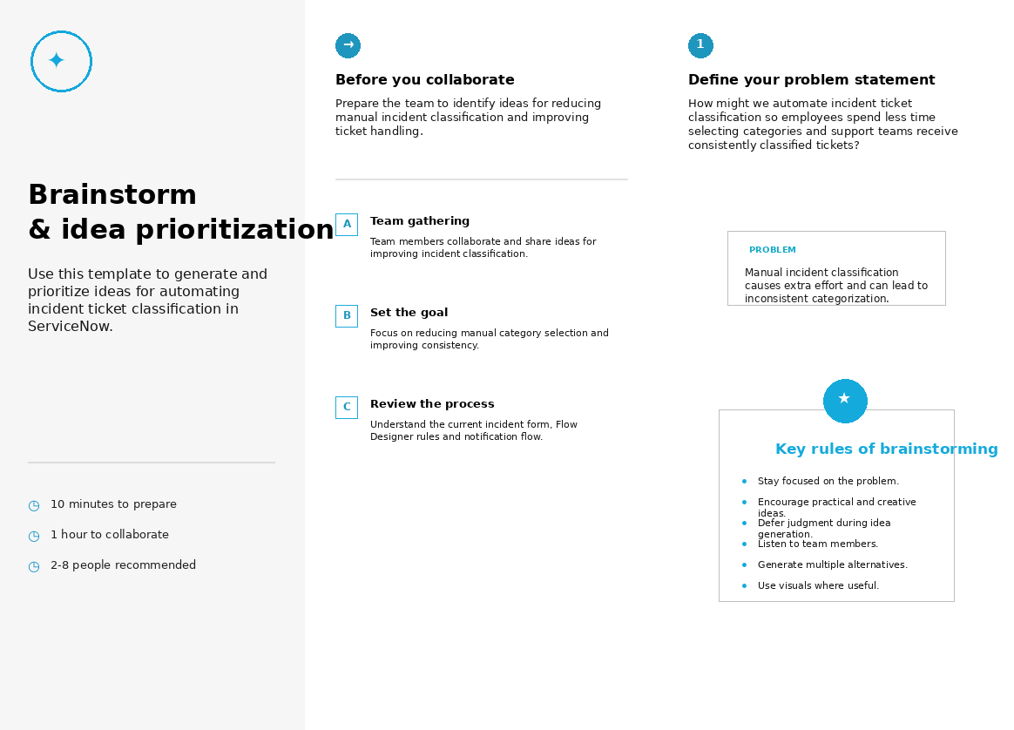

Step-2: Brainstorm, Idea Listing and Grouping
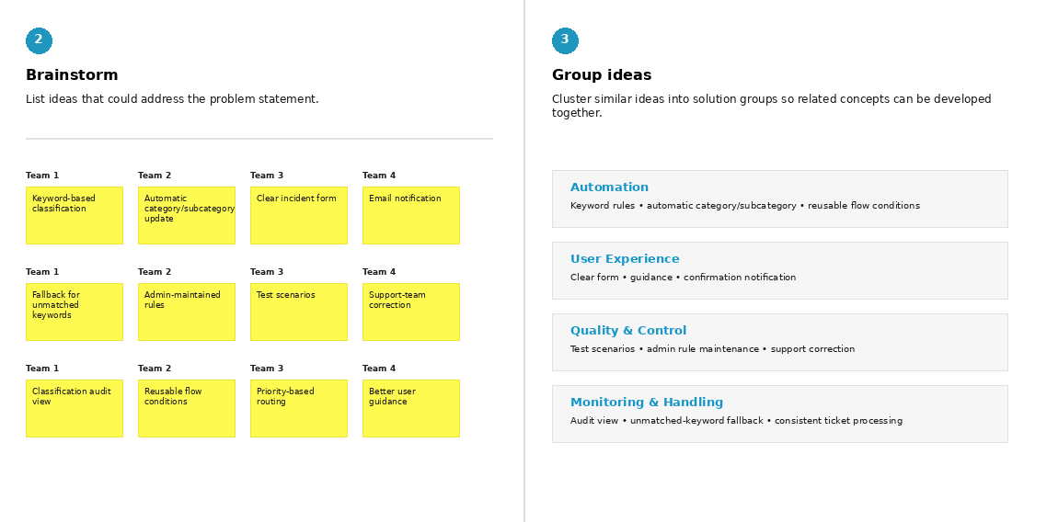

Step-3: Idea Prioritization
